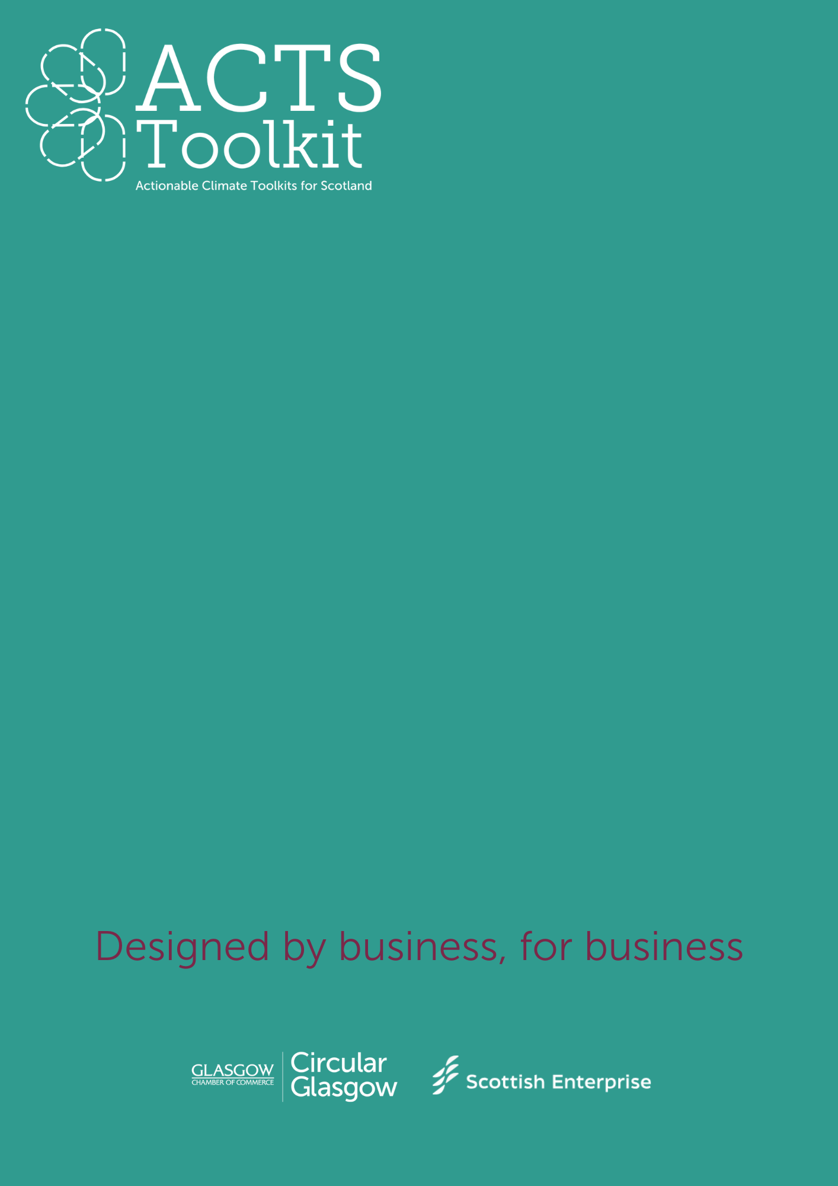
BUILDING YOUR GREEN TEAM
Where to start
Building your
Green Team
Introduction
Appointing a Green Champion or building a Green Team helps to focus your sustainability efforts, promote environmental responsibility, and engage employees in creating a greener, more sustainable business.
Every role has a responsibility for sustainability, working towards net zero and taking advantage of circular opportunities. Having a person or a group of people responsible for driving sustainable change in your business helps to keep everyone accountable.
Mission: Choose your mission – it could be reducing your carbon footprint, or working towards a recognised accreditation such as B-Corp status.
Pick your Team Structure
- Green Team Lead: Responsible for overall direction, coordination, and reporting.
- Team Members: Representing different departments or functions, contributing ideas, and leading initiatives.
- Champion Roles: Specific team members may be assigned as “Green Champions” within their departments.
Key Objectives (examples)
- Reduce energy consumption by X% within X years.
- Cut waste sent to landfill by X% by Xyear.
- Engage employees through X training sessions or workshops annually.
- Collaborate with suppliers to meet sustainability targets.
Key Strategies & Actions (examples)
Consider how will you meet your Key Objectives?
Energy Efficiency:
- Conduct energy audits.
- Implement energy-saving initiatives (LED lighting, HVAC upgrades, etc.).
- Encourage carpooling, biking, or public transport among employees.
Waste Reduction:
- Set up recycling stations in offices and workspaces.
- Introduce a paperless policy or encourage digital document sharing.
- Reduce single-use plastics (e.g., provide reusable cups and bottles).
Employee Engagement:
- Hold monthly sustainability meetings to share progress and ideas.
- Develop sustainability workshops or lunch-and-learns.
- Launch an internal sustainability campaign (e.g., "Green Month").

Timeline & Milestones (examples)
Short-term
- Form Green Team and define initial goals.
- Begin energy audits and waste assessments.
- Host first employee sustainability workshop.
Medium-term
- Start implementing energy-saving measures.
- Roll out recycling programs.
- Begin supplier engagement on sustainability.
Long-term
- Measure progress against set goals (e.g., energy savings, waste reduction).
- Conduct regular team reviews and update strategy as needed.
Resources & Support
- Budget: do you need financial support to deliver changes?
- Training: are there opportunities for learning and development?
- External Partnerships: can you collaborate with others to drive change?
Reporting & Evaluation
- Monthly Check-ins: Regular team meetings to track progress and discuss challenges.
- Quarterly Reporting: Share updates on sustainability metrics (e.g., energy usage, waste reduction, employee engagement) with the entire team/business.
- Annual Review: Evaluate progress against goals, celebrate successes, and adjust strategies for the coming year.
Communication Plan
- Internal: Monthly communications to inform staff about initiatives and progress.
- External: Highlight sustainability achievements on your website, in client communications, and through social media.

