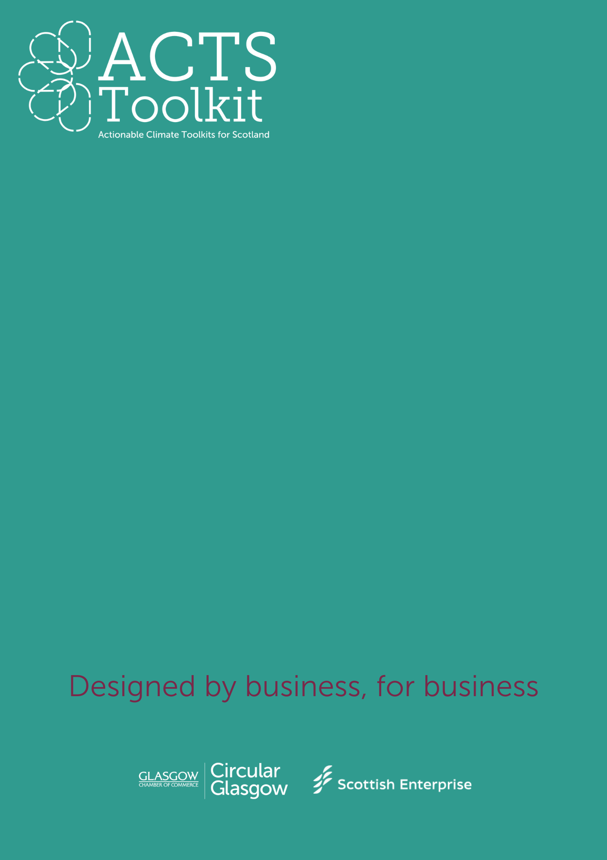
Third Sector and Community Outreach
Guide – Writing a Waste Reduction Plan
GUIDE – WRITING A WASTE REDUCTION PLAN
This document is aimed at supporting SMEs to develop their own Waste Reduction Plan.
SECTION 1 – Introduction
Complete the boxes below:
Company Name
Date of Plan Creation
Responsible person(s)/team(s)

SECTION 2 – Company statement
Your statement should outline your commitment to reducing your waste and improving resource efficiencies, and how this ties into your wider company values on sustainability.
SECTION 3 – Waste Audit Results & Categories
Your waste audit data should be extrapolated to demonstrate a typical volume of waste over a given time period.
Waste Categories
For each waste category, indicate your current waste volume and reduction goal.
Waste Type | Current Volume | Reduction Goal
General Waste
Recyclable Waste
Organic Waste
Hazardous Waste
Electronic Waste
Packaging Waste
Other Waste

SECTION 4 – Carbon Reduction Targets
Outline your SMART targets:
- Specific – what are you going to reduce, and by how much?
- Measurable – how much will you reduce your waste by?
- Actionable – are your goals realistic?
- Relevant – does your reduction goal fit with your company values?
- Timely – how long will it take you to meet your goal?

Timeframe | Goal examples | Progress
Short-term | Over a period of 12 months, we will reduce waste by 20% through better recycling initiatives.
Medium-Term | Within 18 months, we will achieve a 50% reduction in packaging waste by working with our suppliers to develop more sustainable packaging alternatives.
Long-term | By 2030 we will transition to a zero-waste-to-landfill operation by embracing circular economy principles and advanced waste diversion strategies.

Areas to focus on:
- Waste Segregation and recycling
- Sustainable Procurement methods
- Waste prevention through improved design and management
- Reduction of waste at source
- Employee awareness and engagement campaigns
- Circular Economy integration

SECTION 5 – Monitoring & Reporting
Consider how you will track your progress, the frequency of your data collection and who will be responsible for overseeing each area within the business.
Set out your reporting process and frequency – use the table below for guidance:
Emission Source | Baseline Year Value | Current Year Value | Reduction Goal | % Change | Actions taken | Next Steps
General Waste (t) | X (t) | Y (t) | 25% by 2030 |  | Implemented office wide waste segregation. | Review waste contractor arrangements.
Recyclable materials (t) | X t | Y t | 60% by 2030 |  | Partnered with a recycling service provider. | Expand recycling program to all departments.

You may also wish to include:
- Who is responsible for what?
- How frequently this will be reviewed?
- How will you refine your goals?

